in the neighborhood of

The final sort ; as we move to the right with the sub-keys ; there is a limit that we can stop looking for factors. We only need to test to 1/7 or 0.142859. Since seven (7) is our starting point in the search with *fam07. We only need to test for ‘just another thirty away’ until 1/7 of PS.

The limit will need to be adjusted for integer math vs decimal math. The formula is *ratio = [ int(PS * 1/7) + 1 ] or *ratio = [ int(PS * 0.142859) + 1 ]. In the next set of pages will show the groundwork to pick 1/7 as the limit.

In order to determine in the traditional manner if a number is prime we test all values from one (1) all the way to the PS (Prime Suspect).
Example: 7 test from 1 to 7 ( 1 , 2 , 3 , 4 , 5 , 6 , 7 ).
Example: 21 test from 1 to 21 ( 1 , 2 , 3 , 4 , 5 , 6 , 7 , . . . , 20 , 21 ).
Factors are hilted in blue.

The red line is the limit of the test for factors. Test until all numbers are exhausted. The yellow cells with a zero (0) are where the MOD() shows a factor. Think of a multiplication table but it is the opposite it is an integer-division table with the remainder value in the cell. With the MOD() function highlighting the locations of factors. It is a simple ‘line of sight’ to analyze the data.

With seven (7) the ends one (1) and seven (7) are both with a zero (0) and yellow color. All the other columns have a numeric value greater than zero (0) and are light gray. Look at twenty-one (21) ; the columns for three (3) and seven (7) are zero (0) and yellow color. This is a visual presentation of the data to tune your thinking and eyesight as we move forward.

Overlaying the above MOD() table is the opposite , a multiplication table. Looking at the green cell diagonally down the middle is the square of the PS (Prime Suspect).
7 * 7 = 49 ; 21 * 21 = 441.

This is the square and a ratio – how did I get here ? Maybe not needed !!!!!!!!!!
This chart shows all numbers and – when the PSL is equal to an integer ; take and square PS then multiply by the ratio ( 1/PS ) . Divide that number (ratio * sq) by PS to get an integer value ‘try’. Paint the row with fill of 25%.
Got me nothing – but a pretty graph based on the weight of the numbers. No solid answer. Not enough time left.

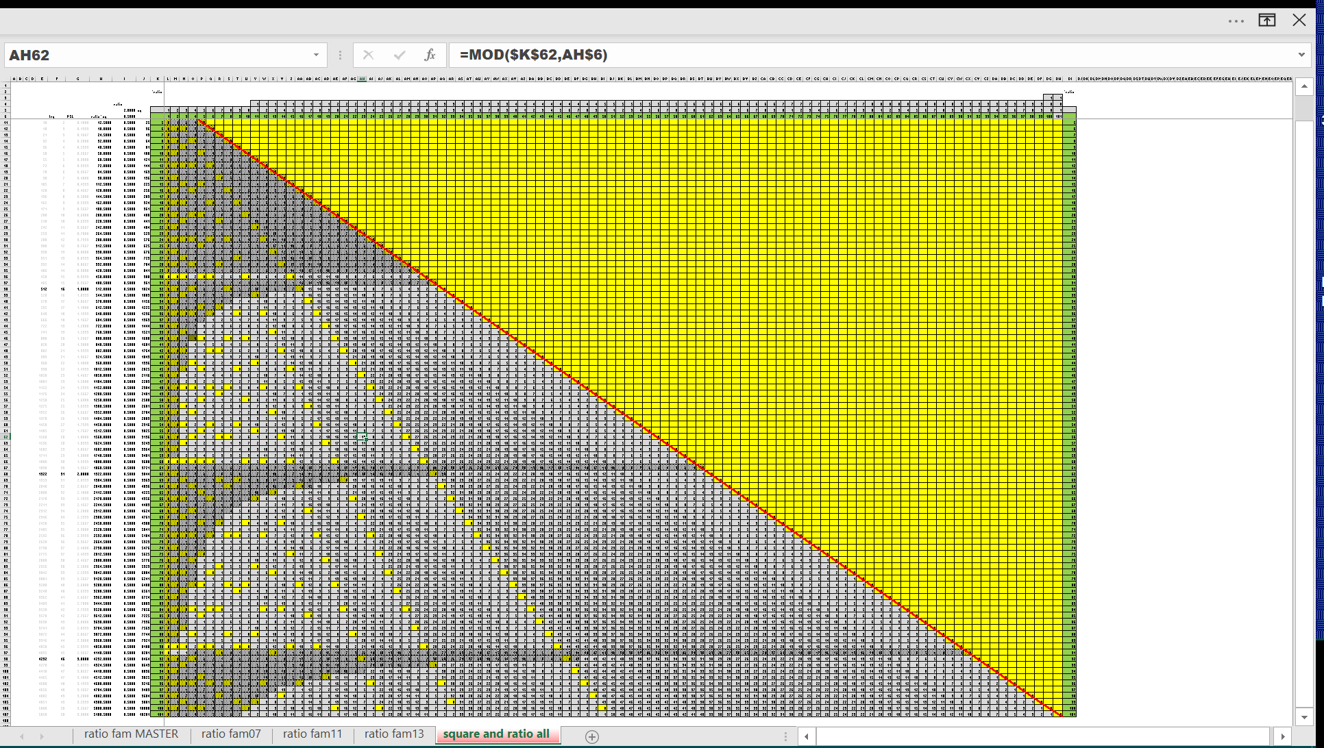

This is the inverse of the *fam for the eight equations.
Generated by “1 seventh 0b.xlsx”
Use tab “ratio look up” to test data.

On to the next search . . .
The far-right red slash is the corner away from the PS. It is the column of PS.
The red boxes and red numbers inside are the value of seven (7) and its MOD()=0.
This is 1/7 (0.142859) of the total for the row.
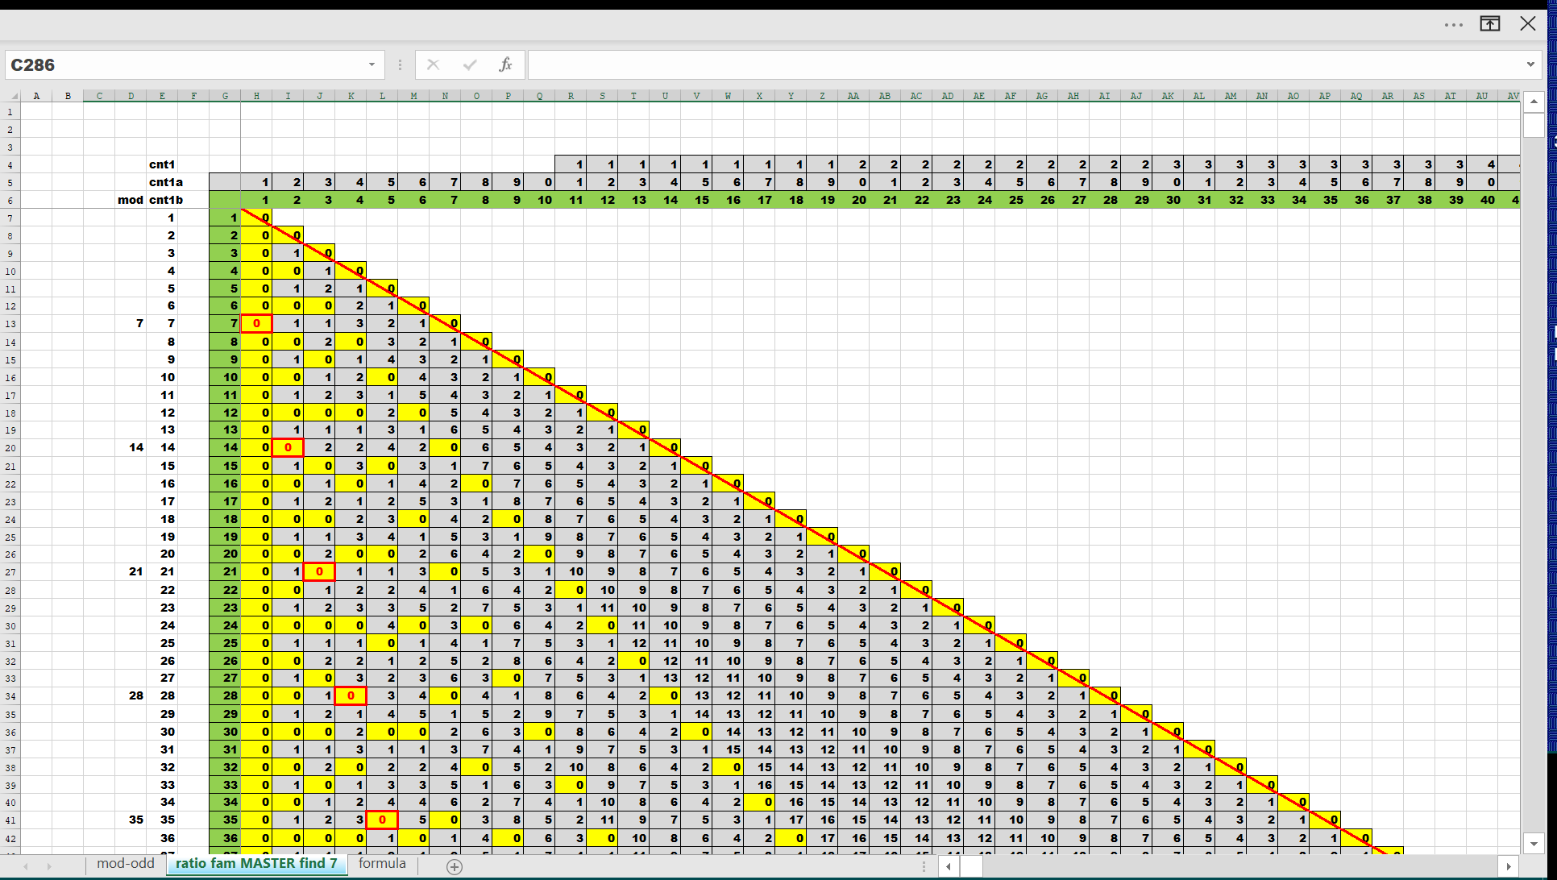

All other *fam are less than 1/7.
*fam01 = 1/1 = 1 (highest probability of prime)
*fam07 = 1/7 = 0.124859
*fam11 = 1/11 = 0.090909
*fam13 = 1/13 = 0.076923
*fam17 = 1/17 = 0.058823
*fam19 = 1/19 = 0.052631
*fam23 = 1/23 = 0.043478
*fam29 = 1/29 = 0.034482 (lowest probability of prime)

The last sort – start here
Everything to the left of the red 7 boxes is where to look up to after making the right turn. It is the limit of the search using the sub-keys.

The three below screen prints are contiguous segments showing *fam07 and 1/7 and 0.142859.
Note the curve formed by the weight of the numbers. The numbers by themselves present a graph. Follow the seven line. The sets of lines to the right of *fam07 are *fam01 , *fam02 , *fam03 , . . . , *fam06. Which have been discarded using prior sorts.

Take note in the 2nd and 3rd slides of the wave to the left of *fam07. More latter some other day. These appear to be of a mammatus formation.

The groundwork has been laid on to ‘in the neighborhood of’ . . .
try = int( PS / 7 ) + 1

Look at 23 – prime ; look at all of his neighbors. There is at least one yellow zero within the number of tries four (4).

Looking at 59 and 61 , both fall in the ‘try’ of nine (9).

The nine column is the max number of tries. The other values ‘in the neighborhood’ have at least one yellow zero within the number of tries nine (9).
If it has not happened within nine (9) tries it is not going to happen. Must be prime.

Looking at 79 and 83 , both fall in the ‘try’ of twelve (12).

The twelve column is the max number of tries. The other values ‘in the neighborhood’ have at least one yellow zero within the number of tries twelve.
If it has not happened within twelve (12) tries it is not going to happen. Must be prime.

Looking at 101 and 103 , both fall in the ‘try’ of fifteen (15).
The fifteen column is the max number of tries. The other values ‘in the neighborhood’ have at least one yellow zero within the number of tries fifteen.
If it has not happened within fifteen (15) tries it is not going to happen. Must be prime.

Here is an image of a range surrounding two primes (134999 and 135007) and their
“in the neighborhood’ numbers.

Bigger view.

Test up to try = 19,286 for prime 134,999
Test up to try = 19,287 for prime 135,007

Here is an image of a range surrounding two primes (1234570321 and 1234570327) and their “in the neighborhood’ numbers.

Bigger view.

Test up to try = 176,369,482 for prime 1,234,570,321

Test up to try = 176,369,483 for prime 1,234,570,327

By setting a limit to ‘try’ to equal to 1/7 we have eliminated 6/7’s of the numbers to test.
Sorted off 6/7’s.

